Courtney Gosselin

Wasi-ul- Hassan Raza

Anne Brecklinghaus

London Taylor

Dr Mohammad (Khalad) Hasan

COSC 341

Nov 4, 2018

**Family Schedule Application**

Project Step 3: Gather Requirements

**Three Major Tasks:**

1. View calendar as daily, weekly, or monthly for specific persons
2. Edit events
3. Parents approving kids requested events

**Paper Prototypes:**

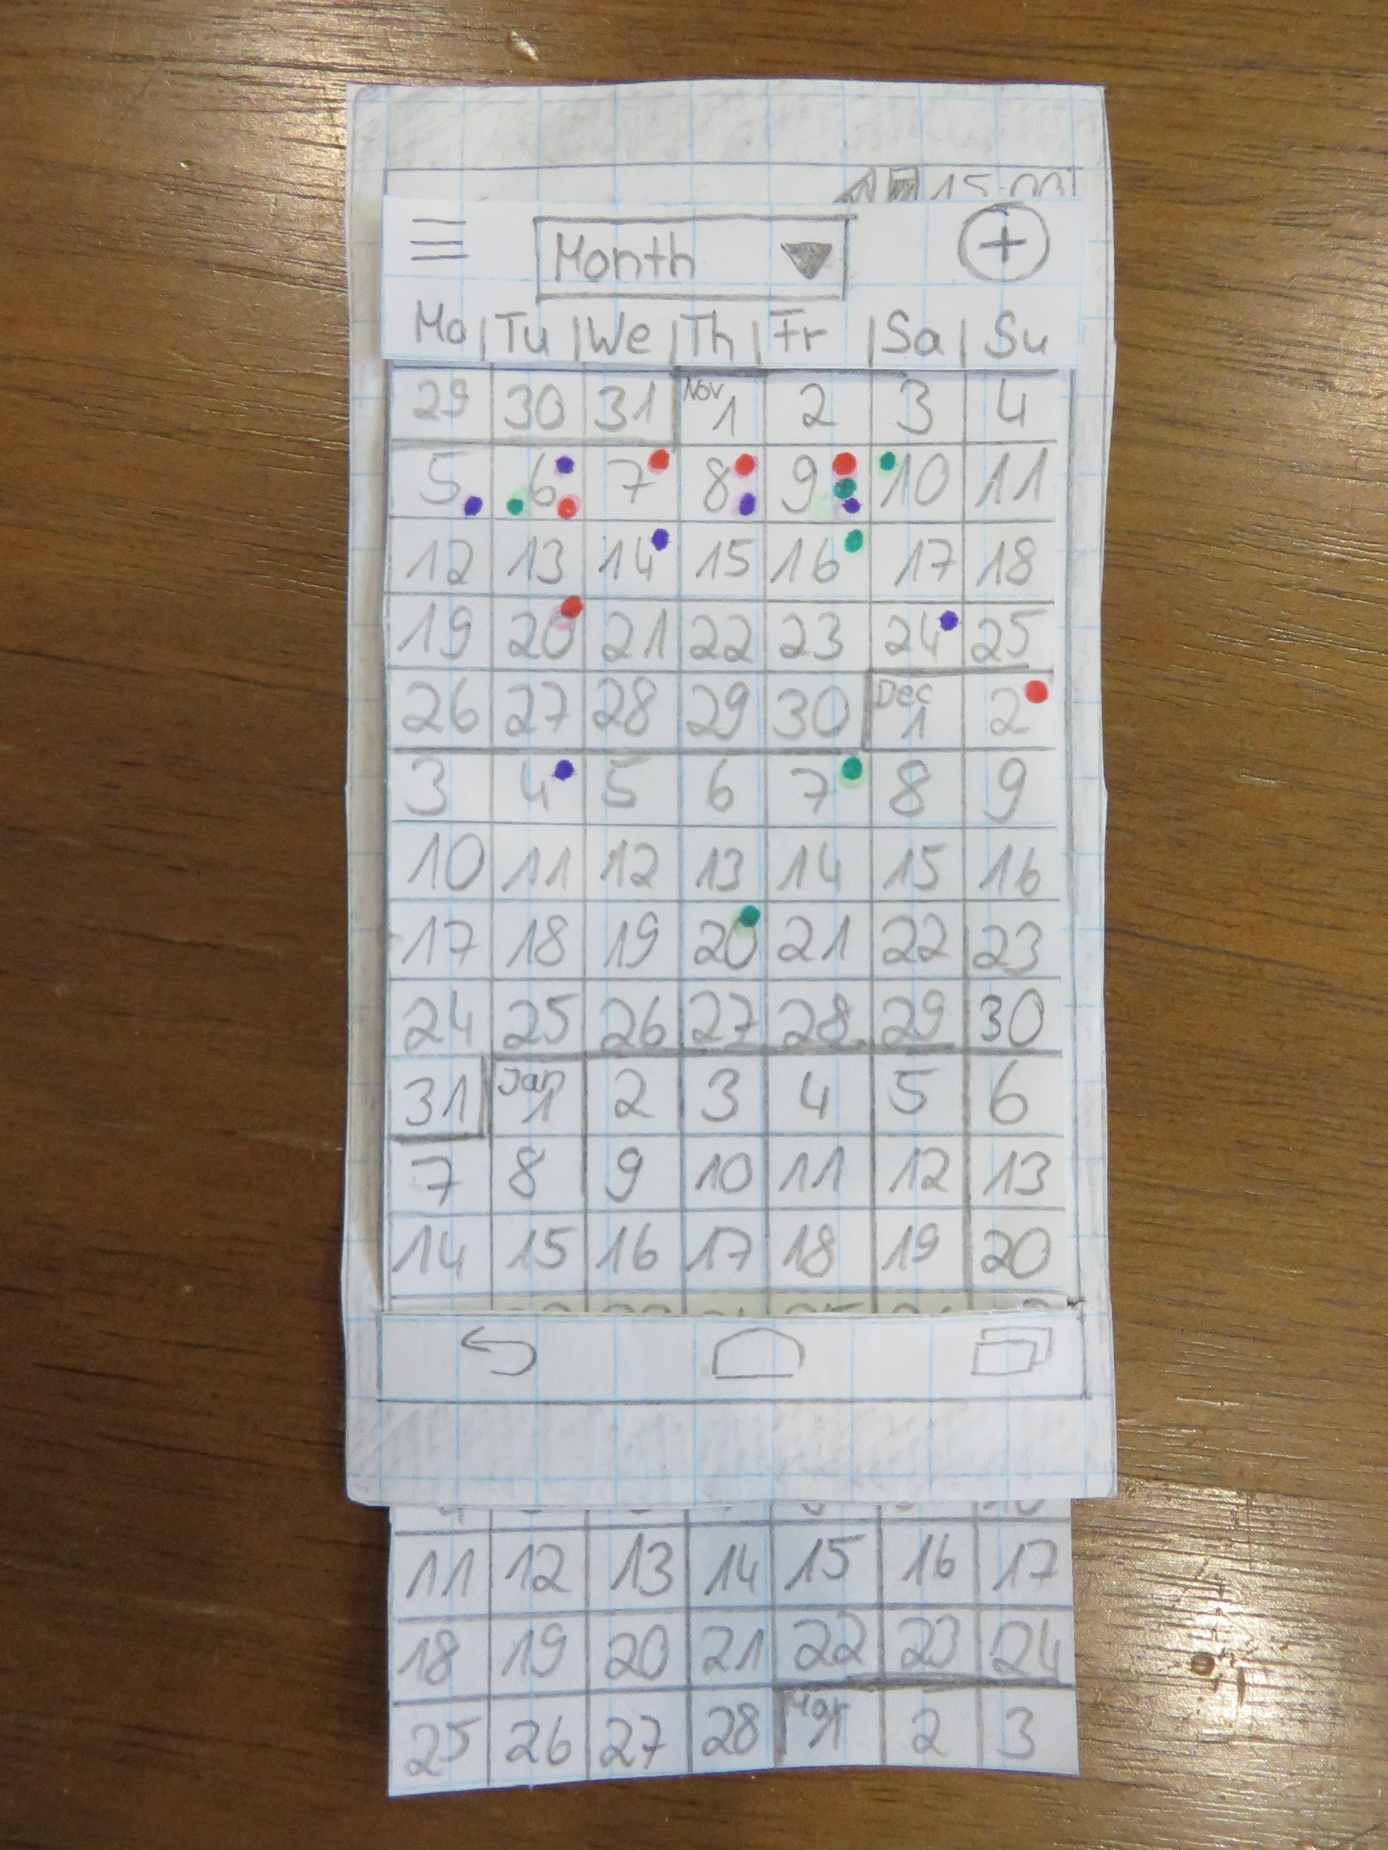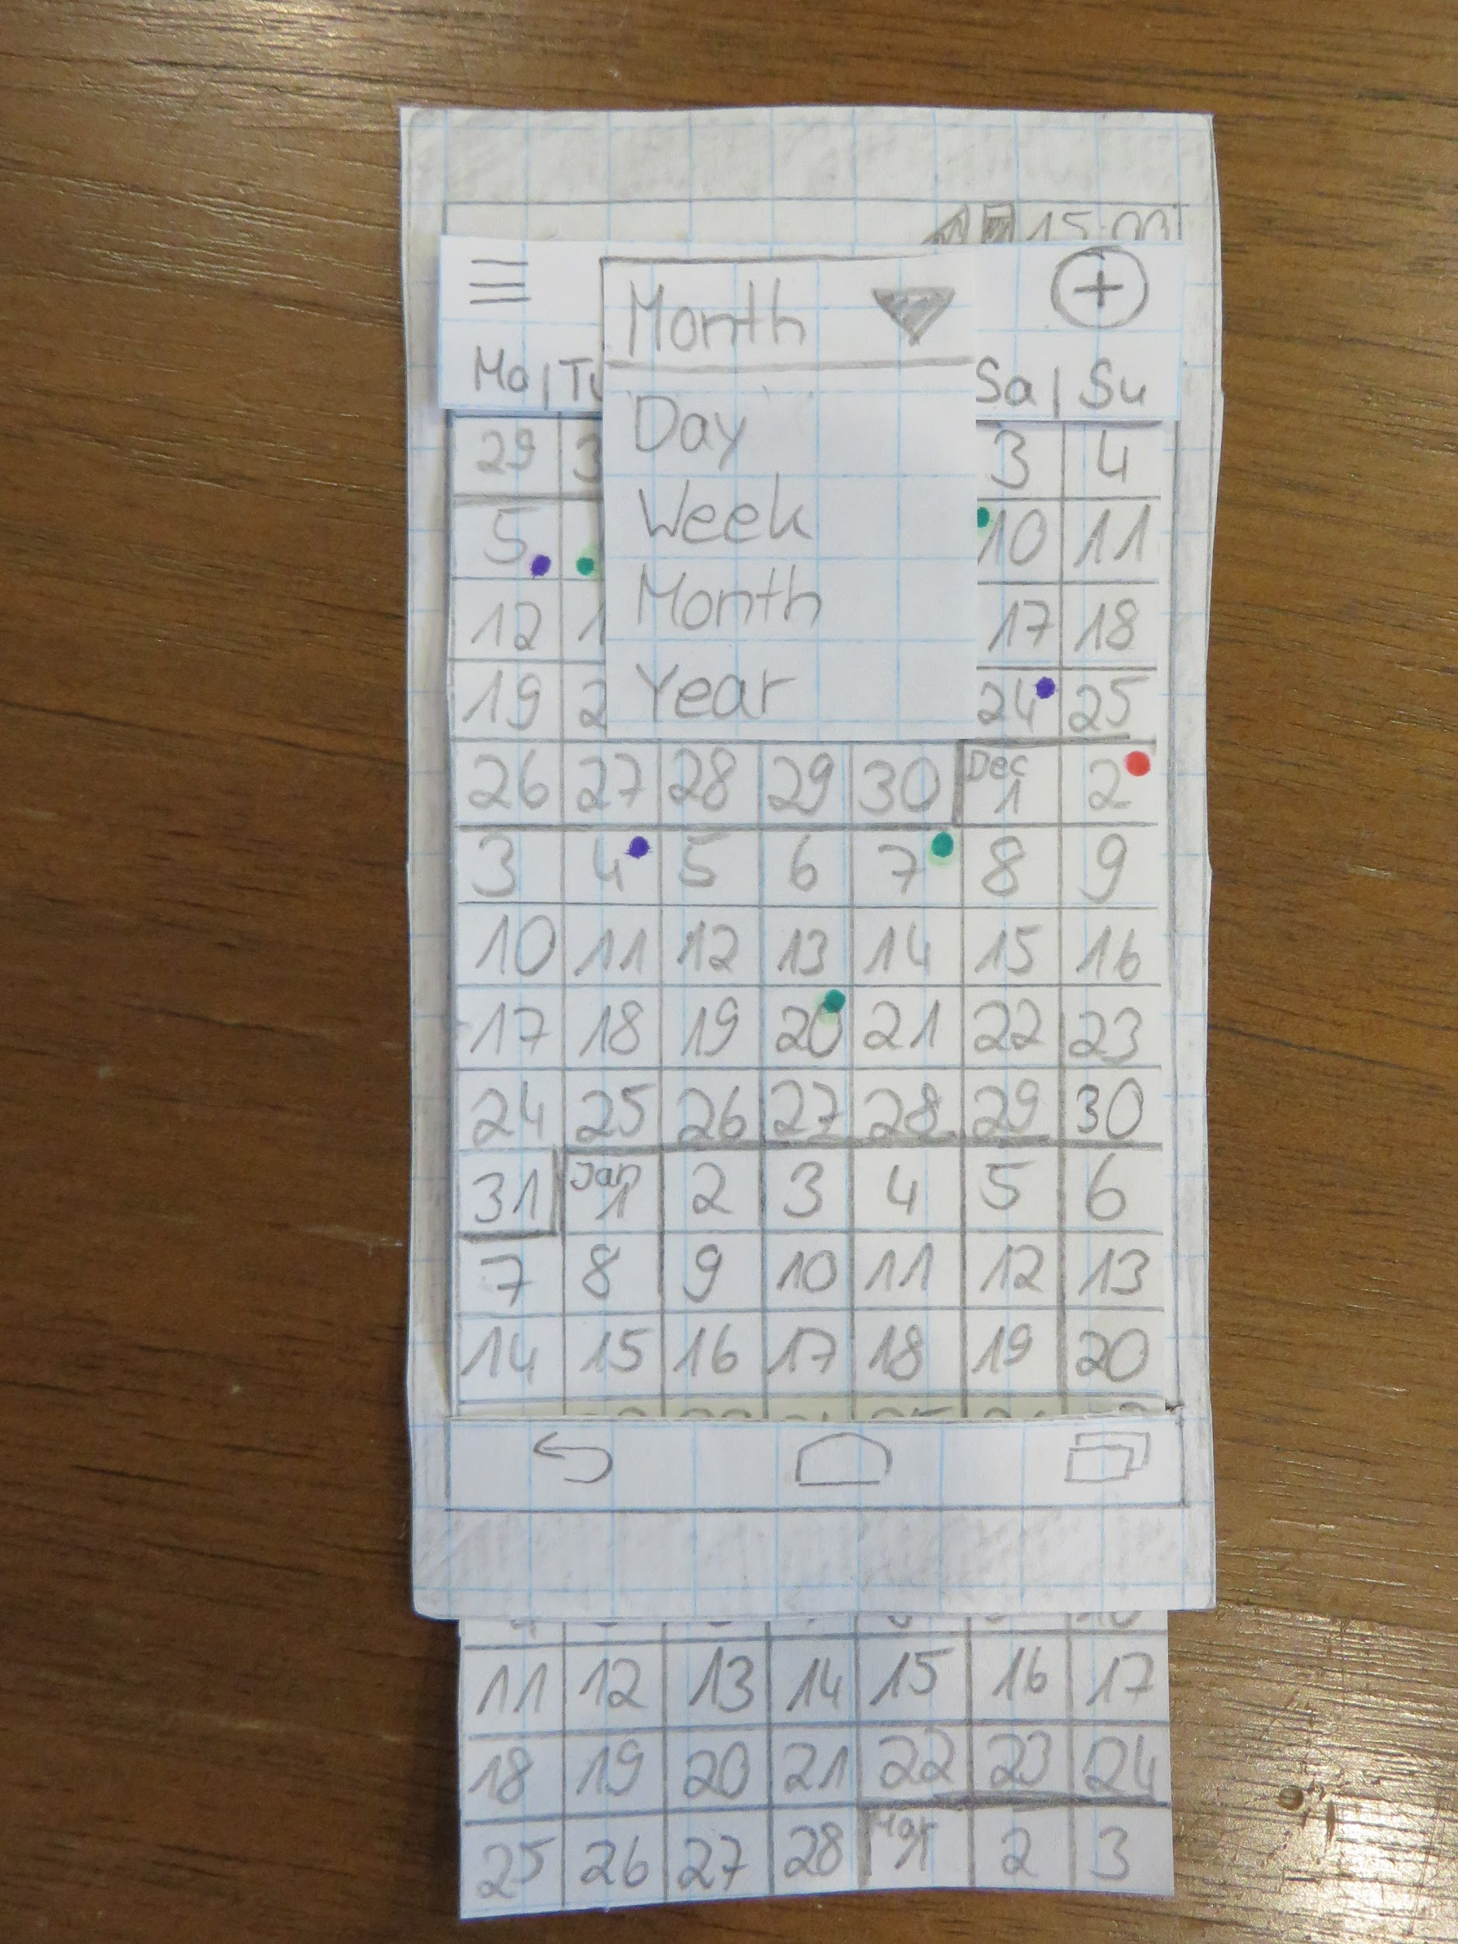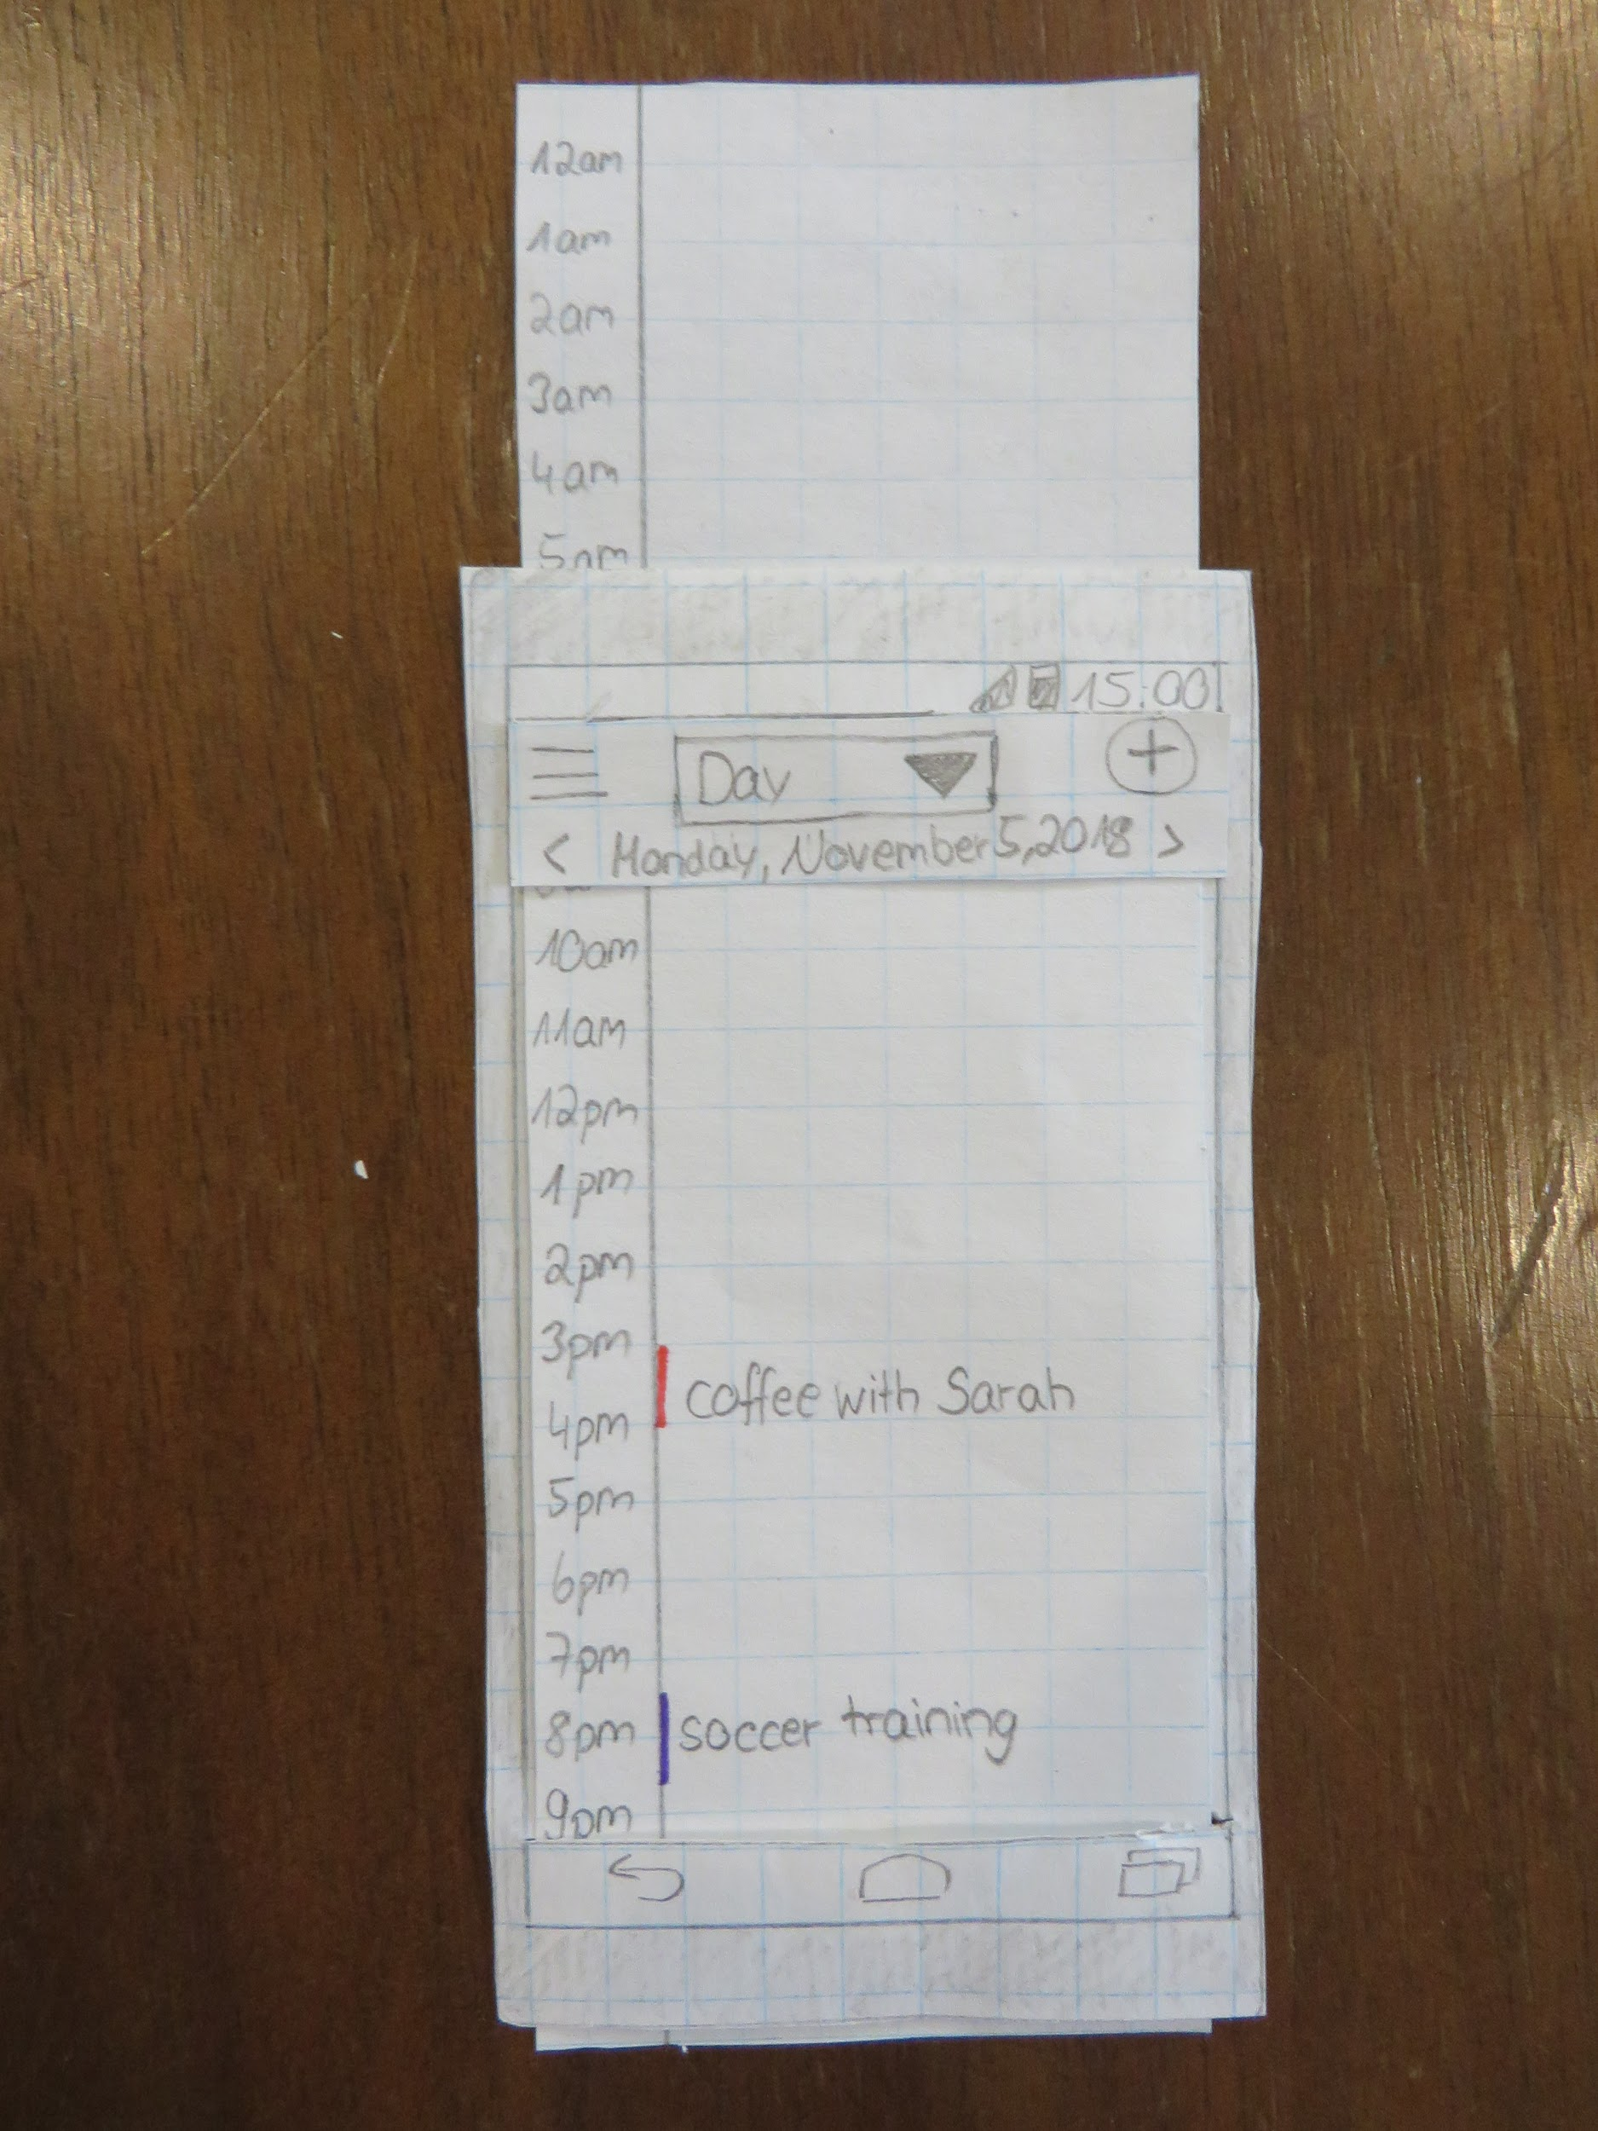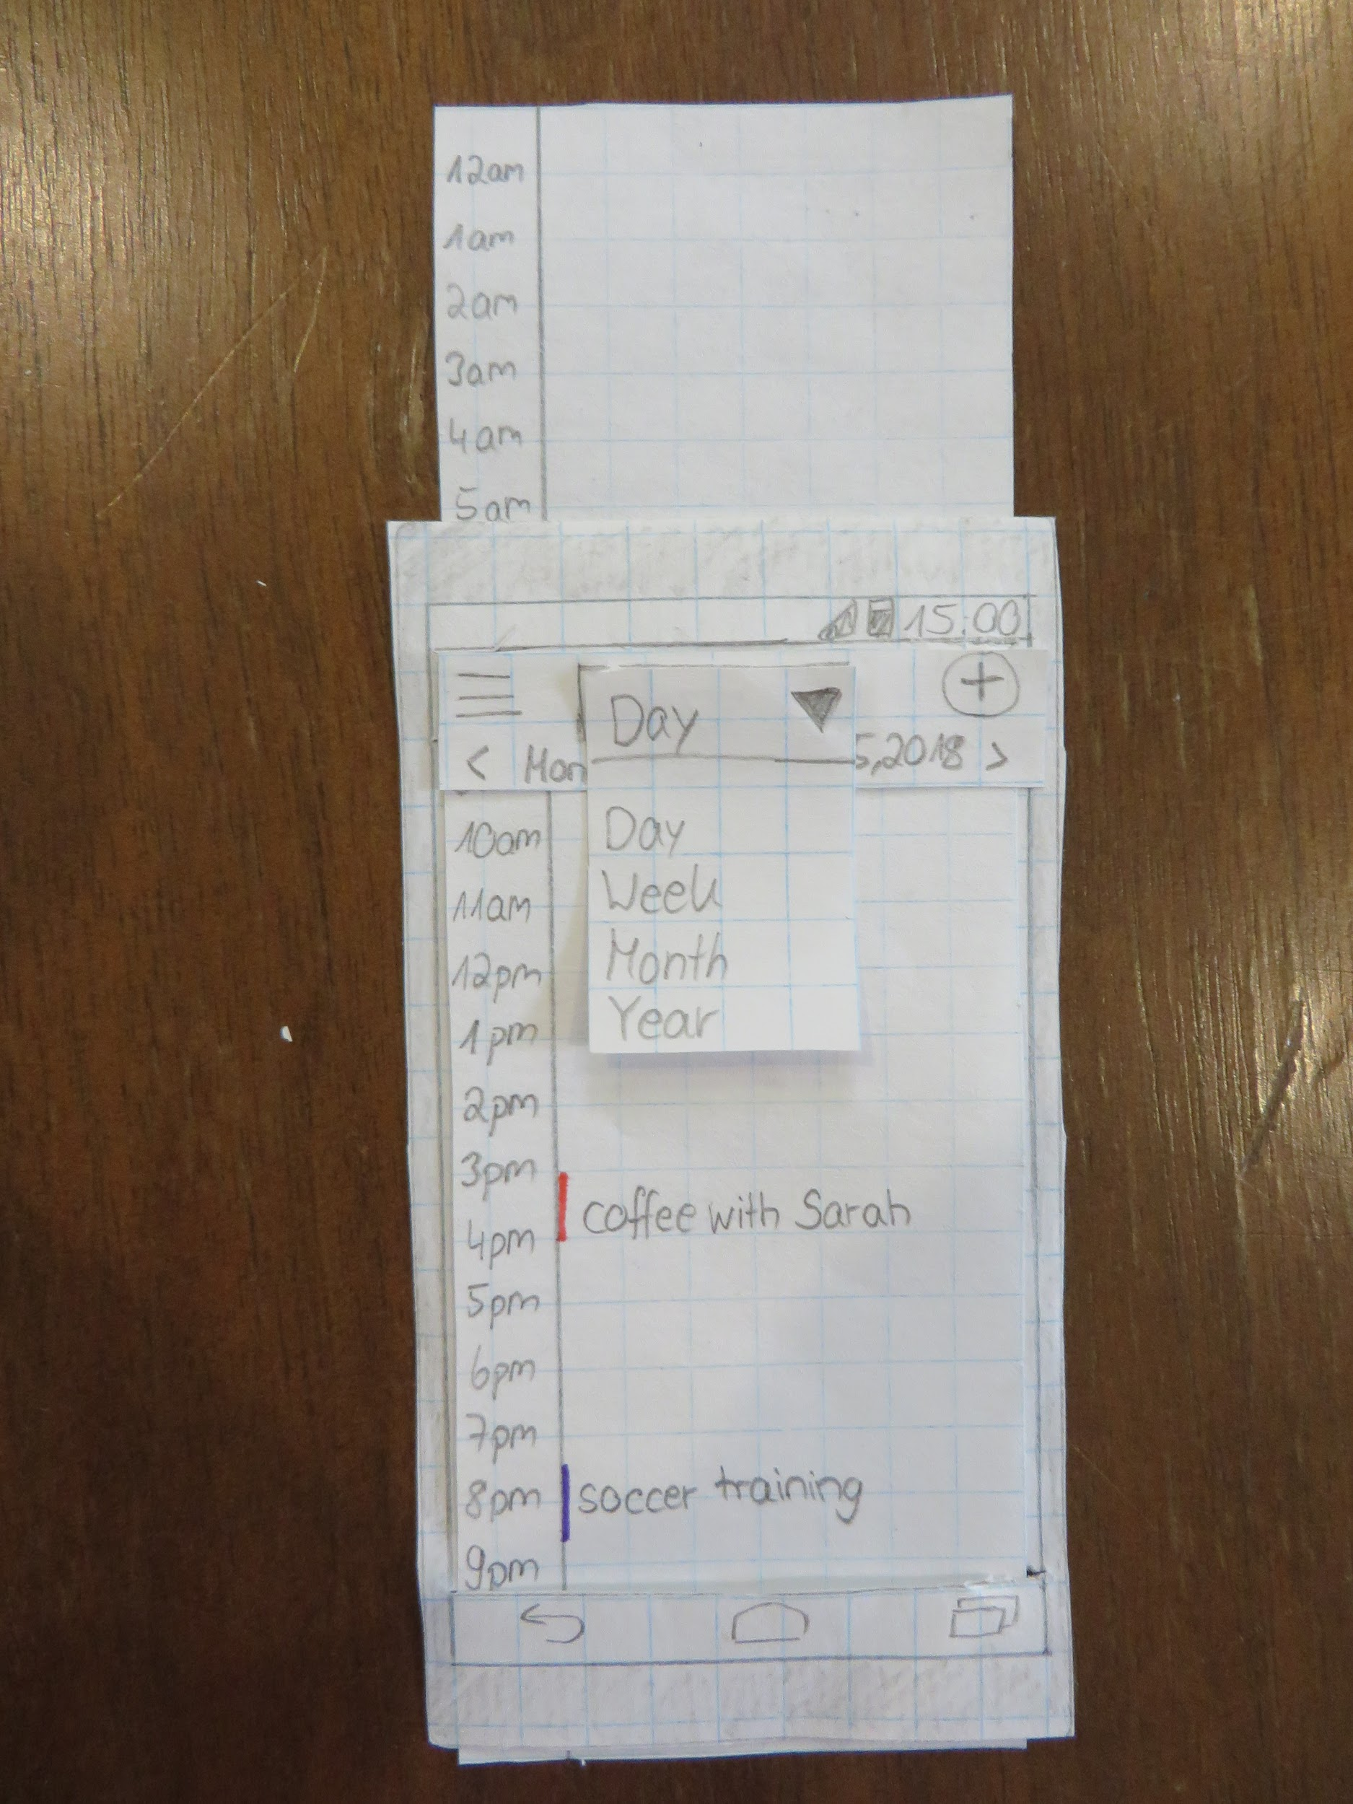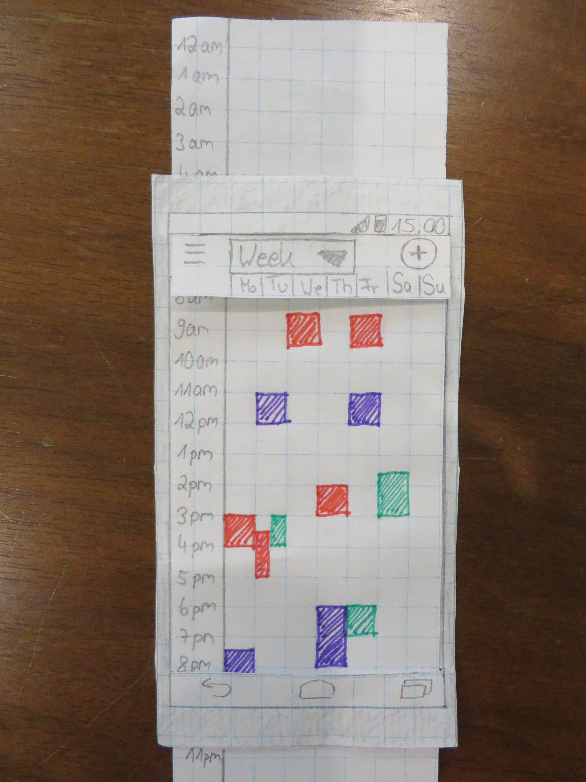

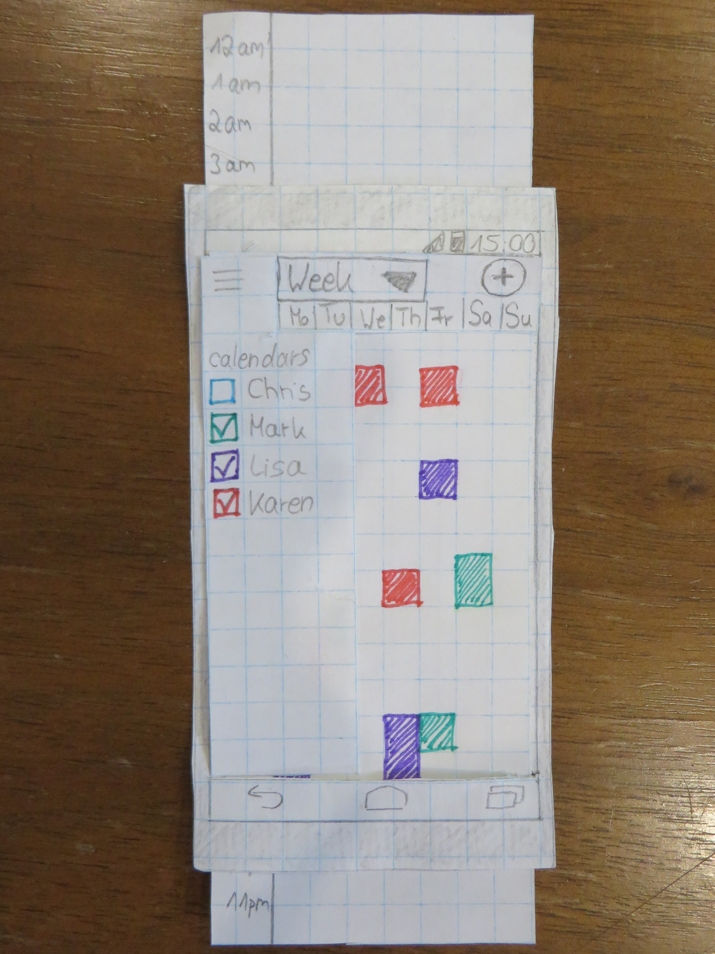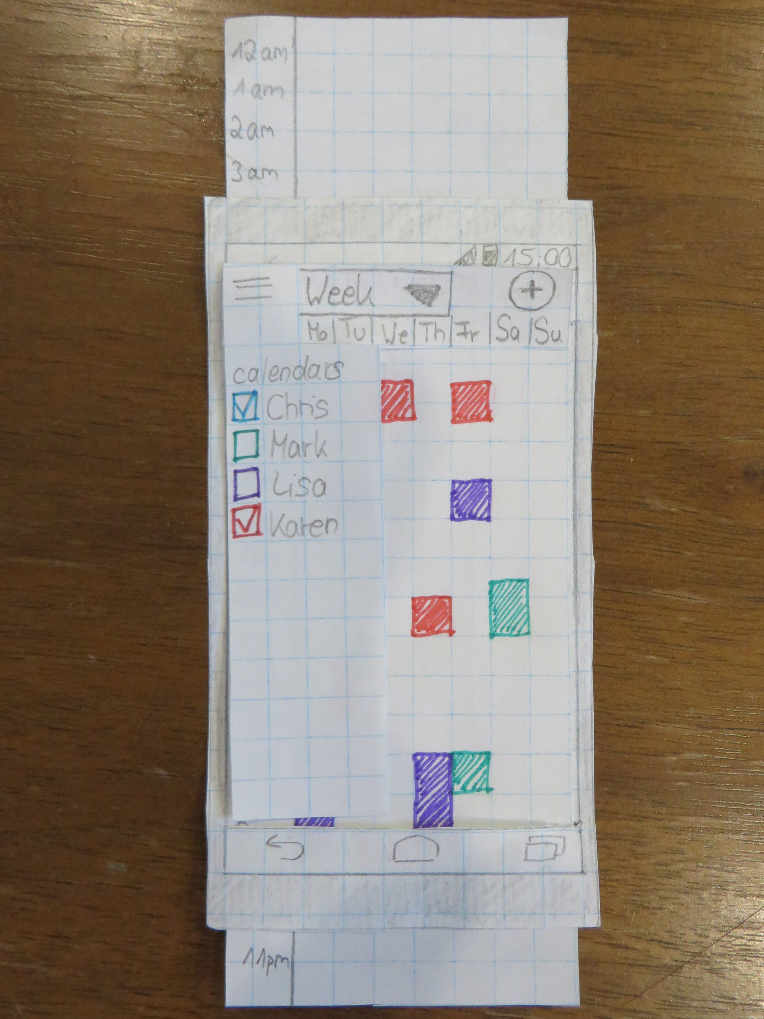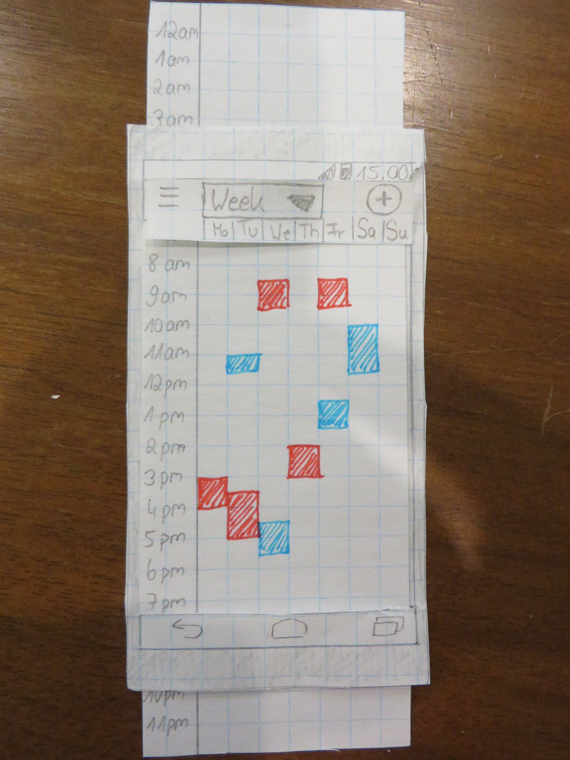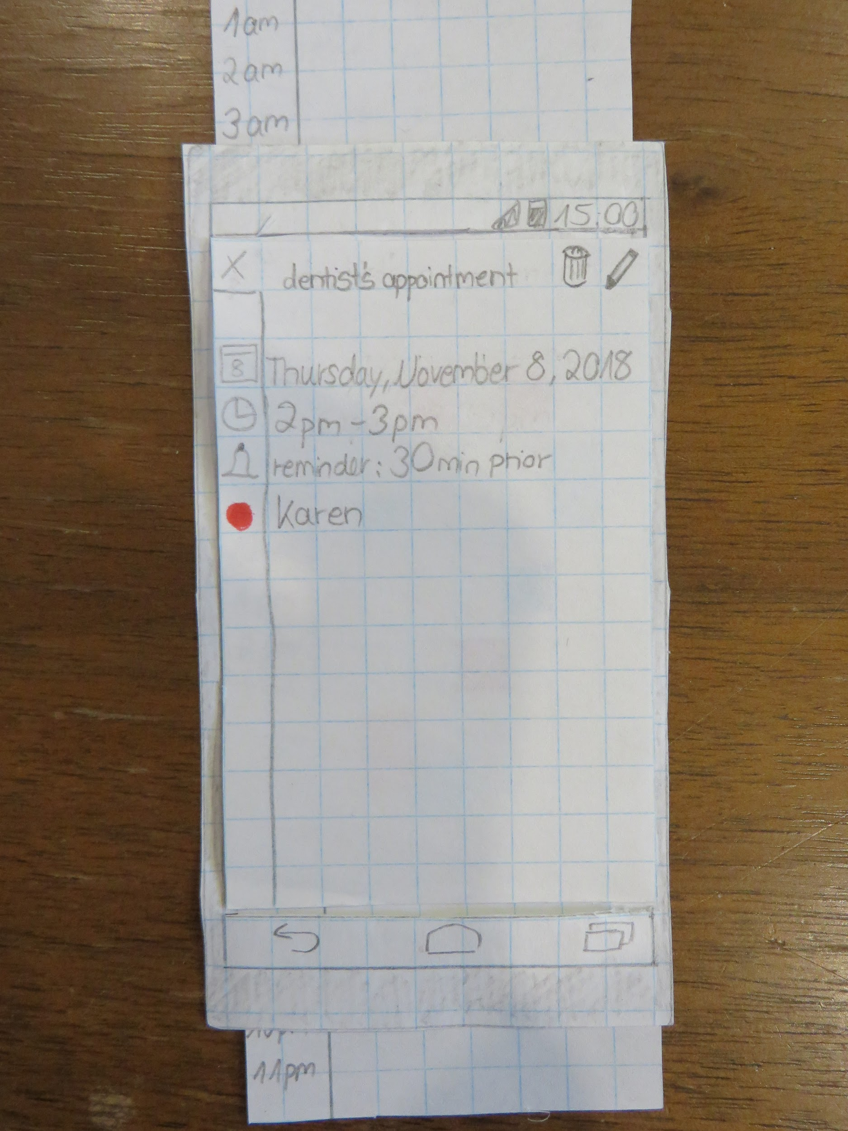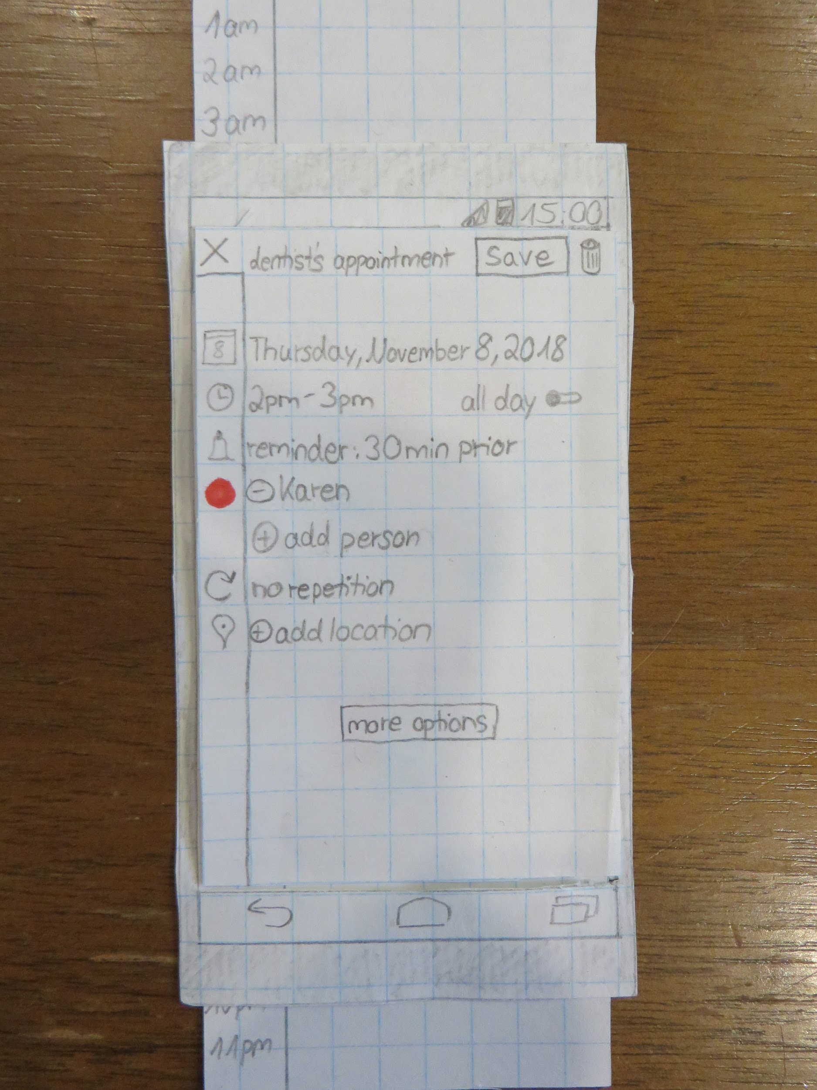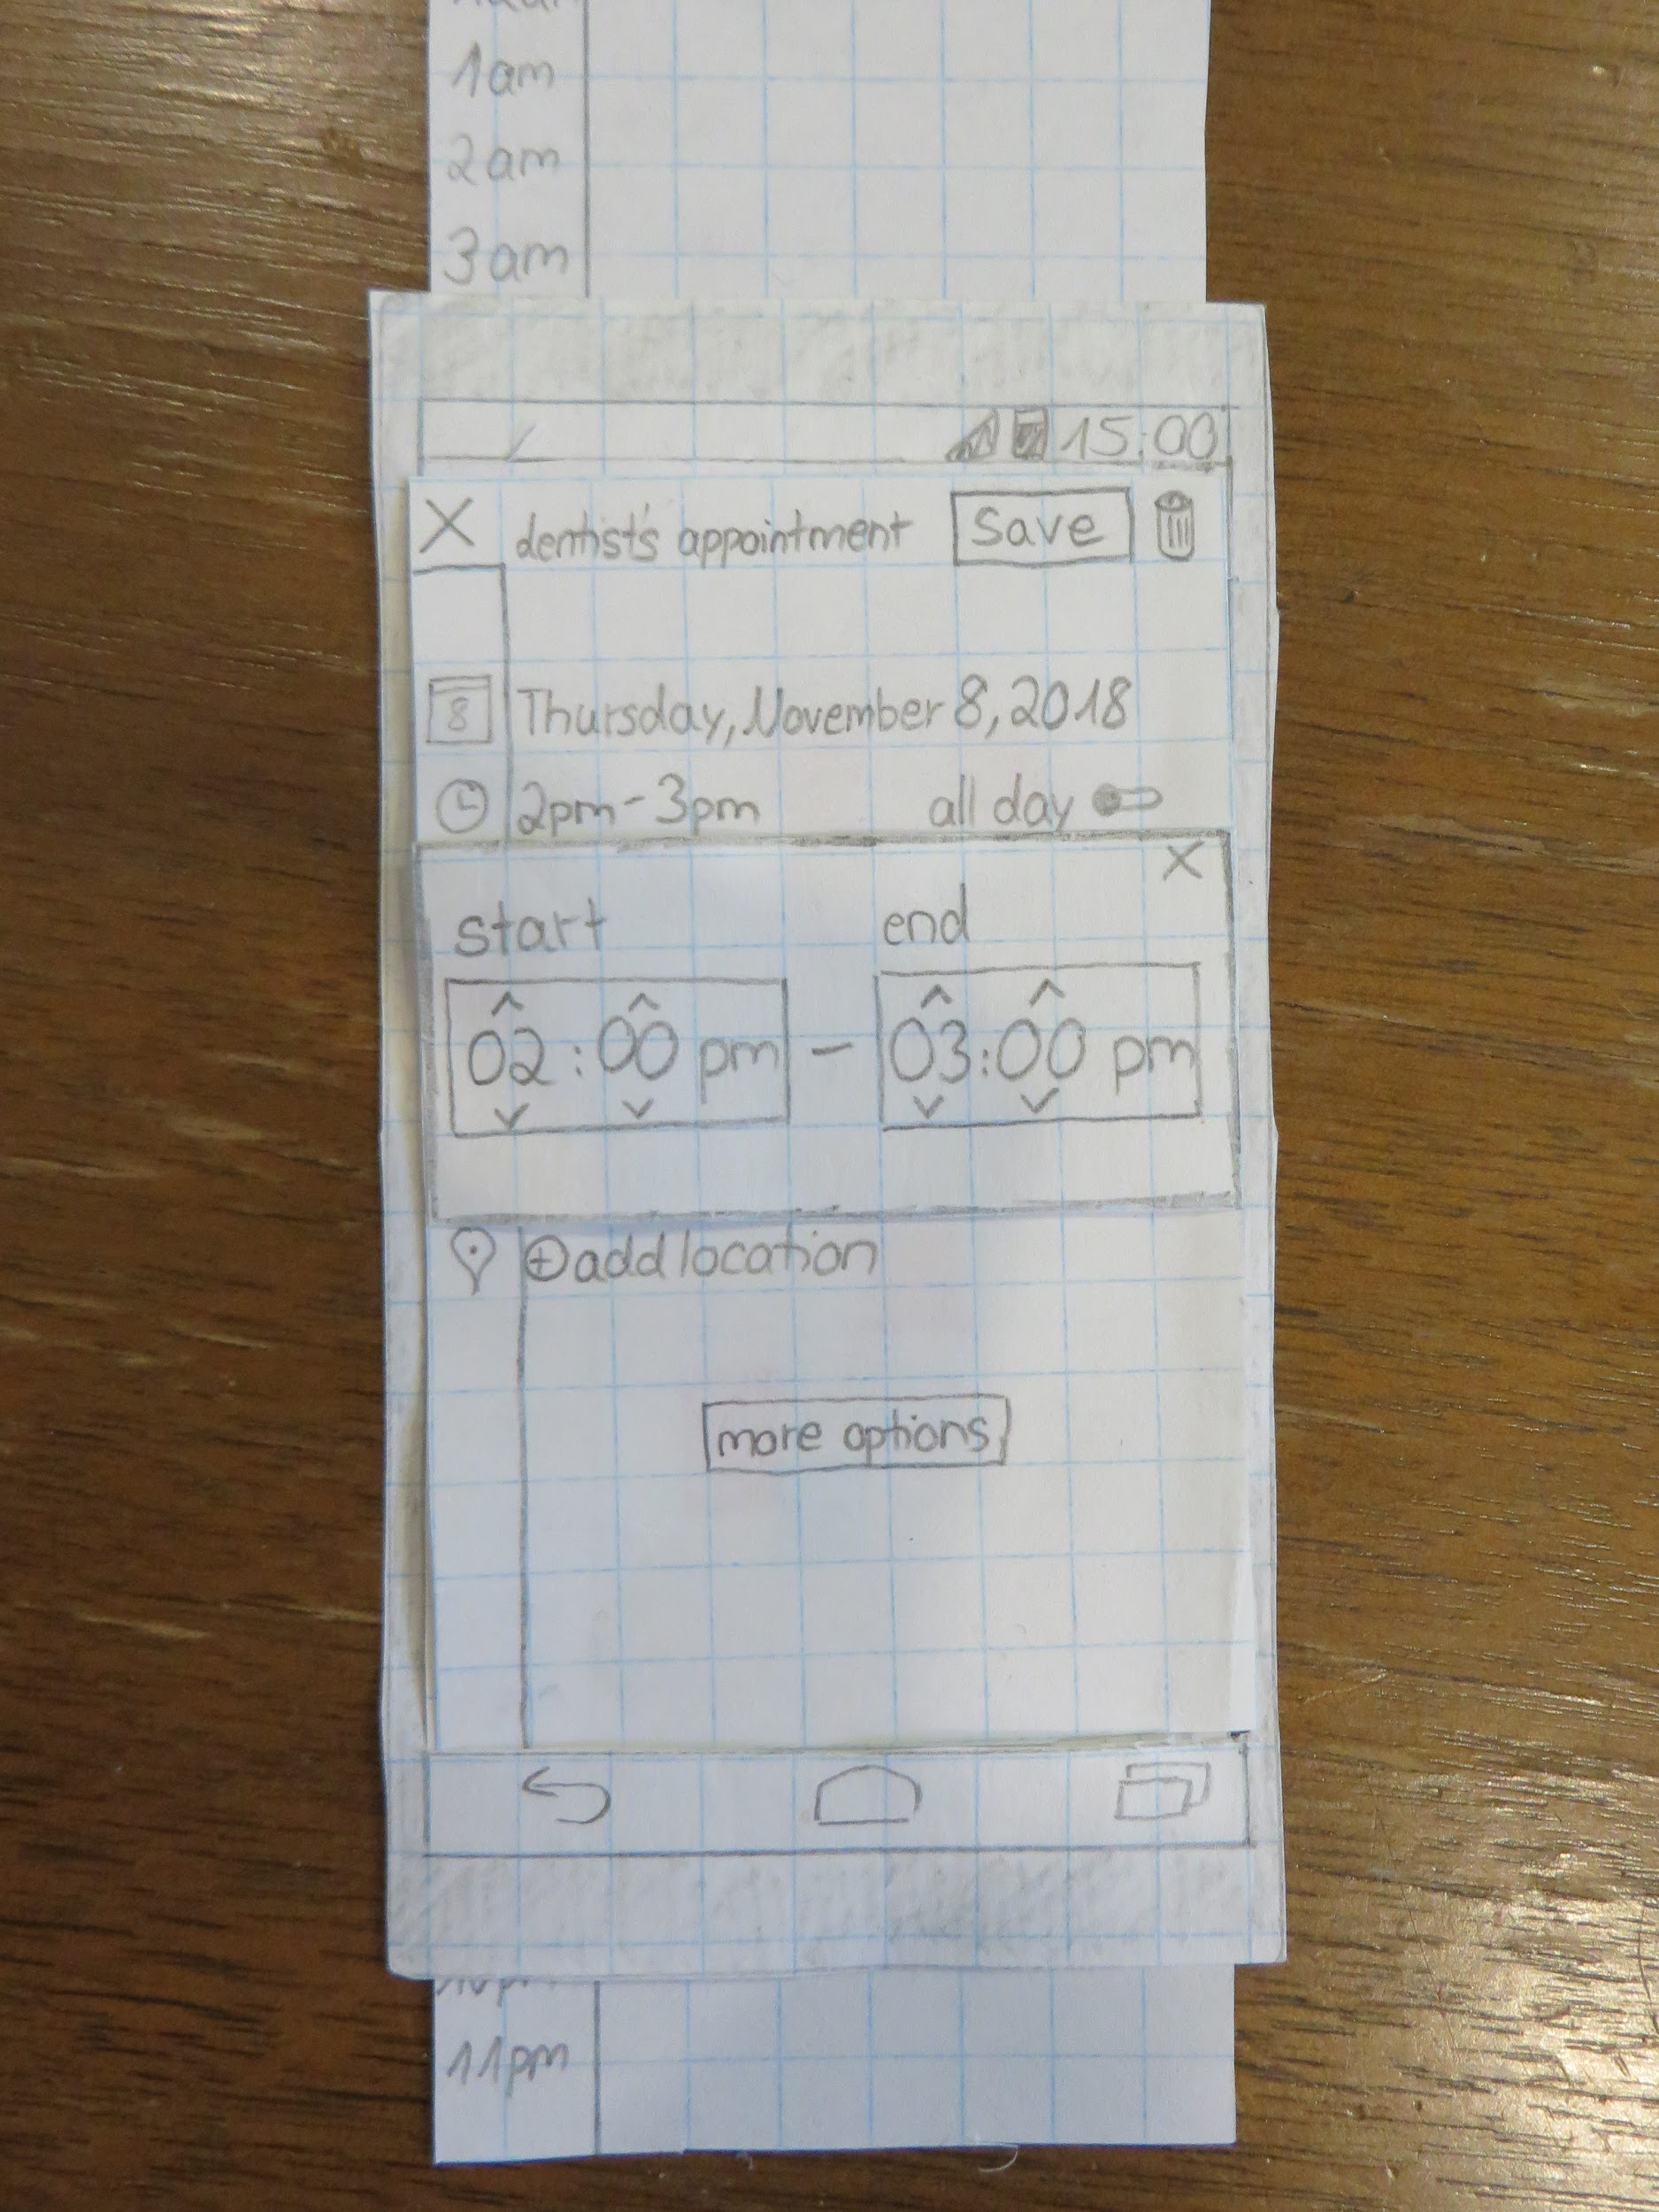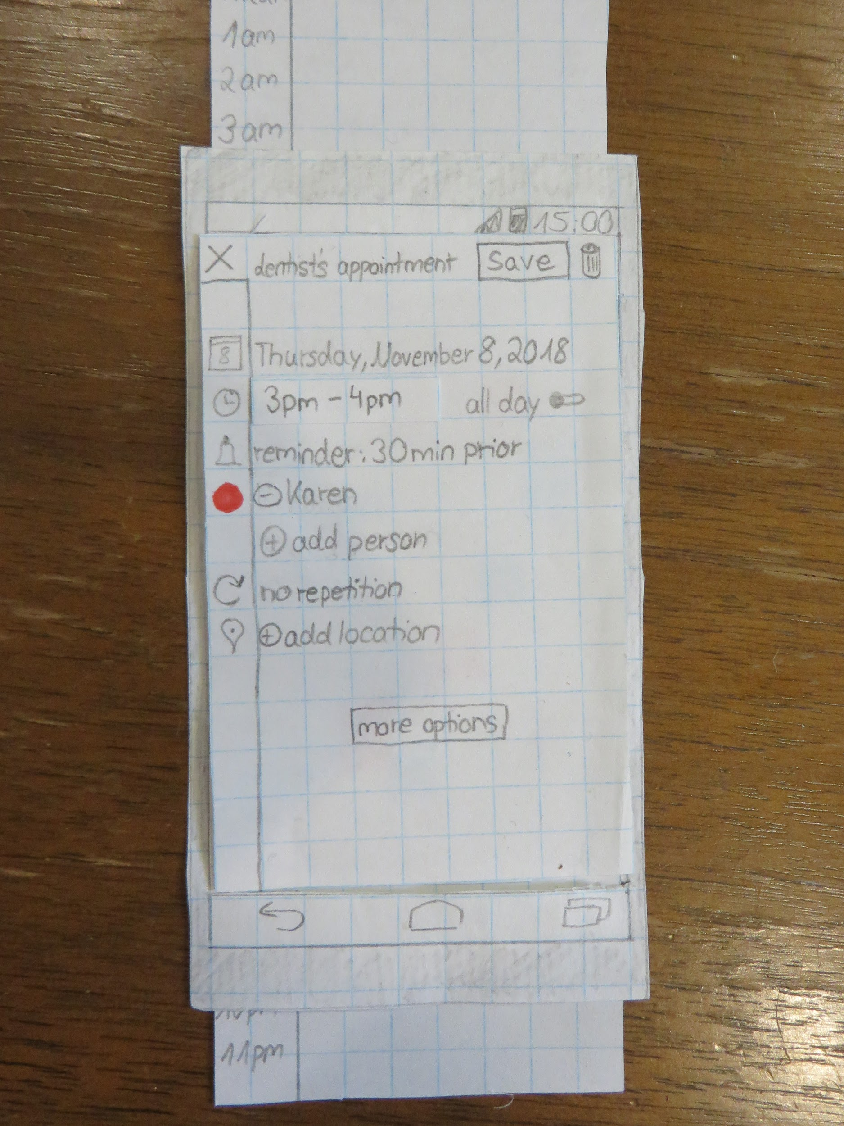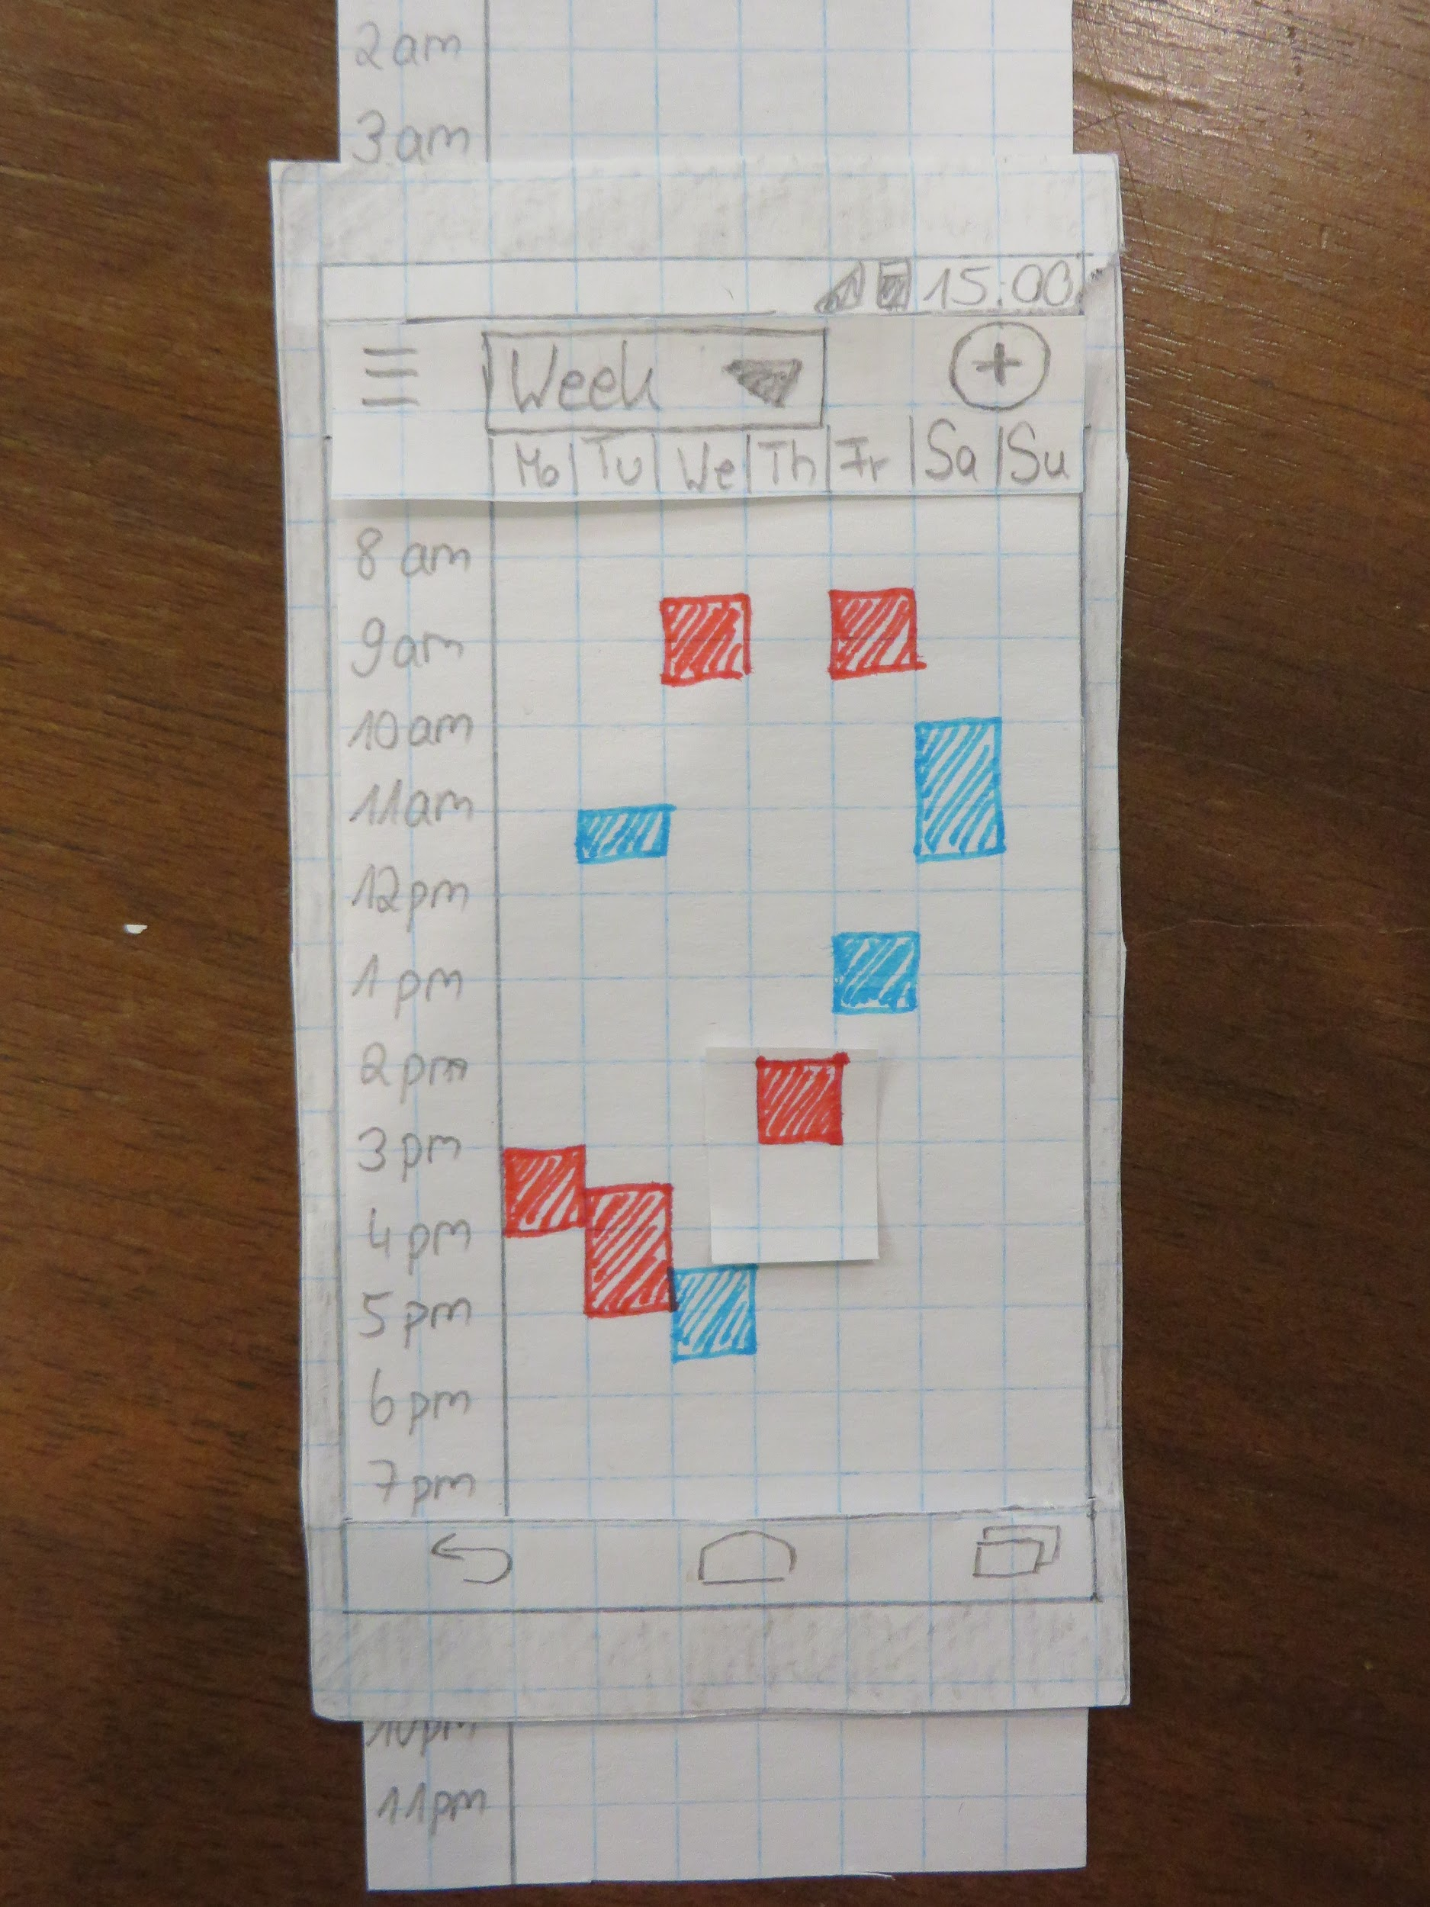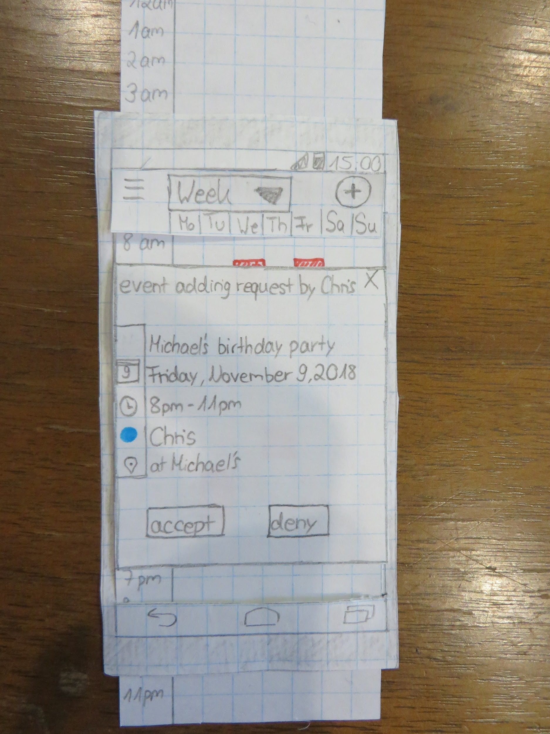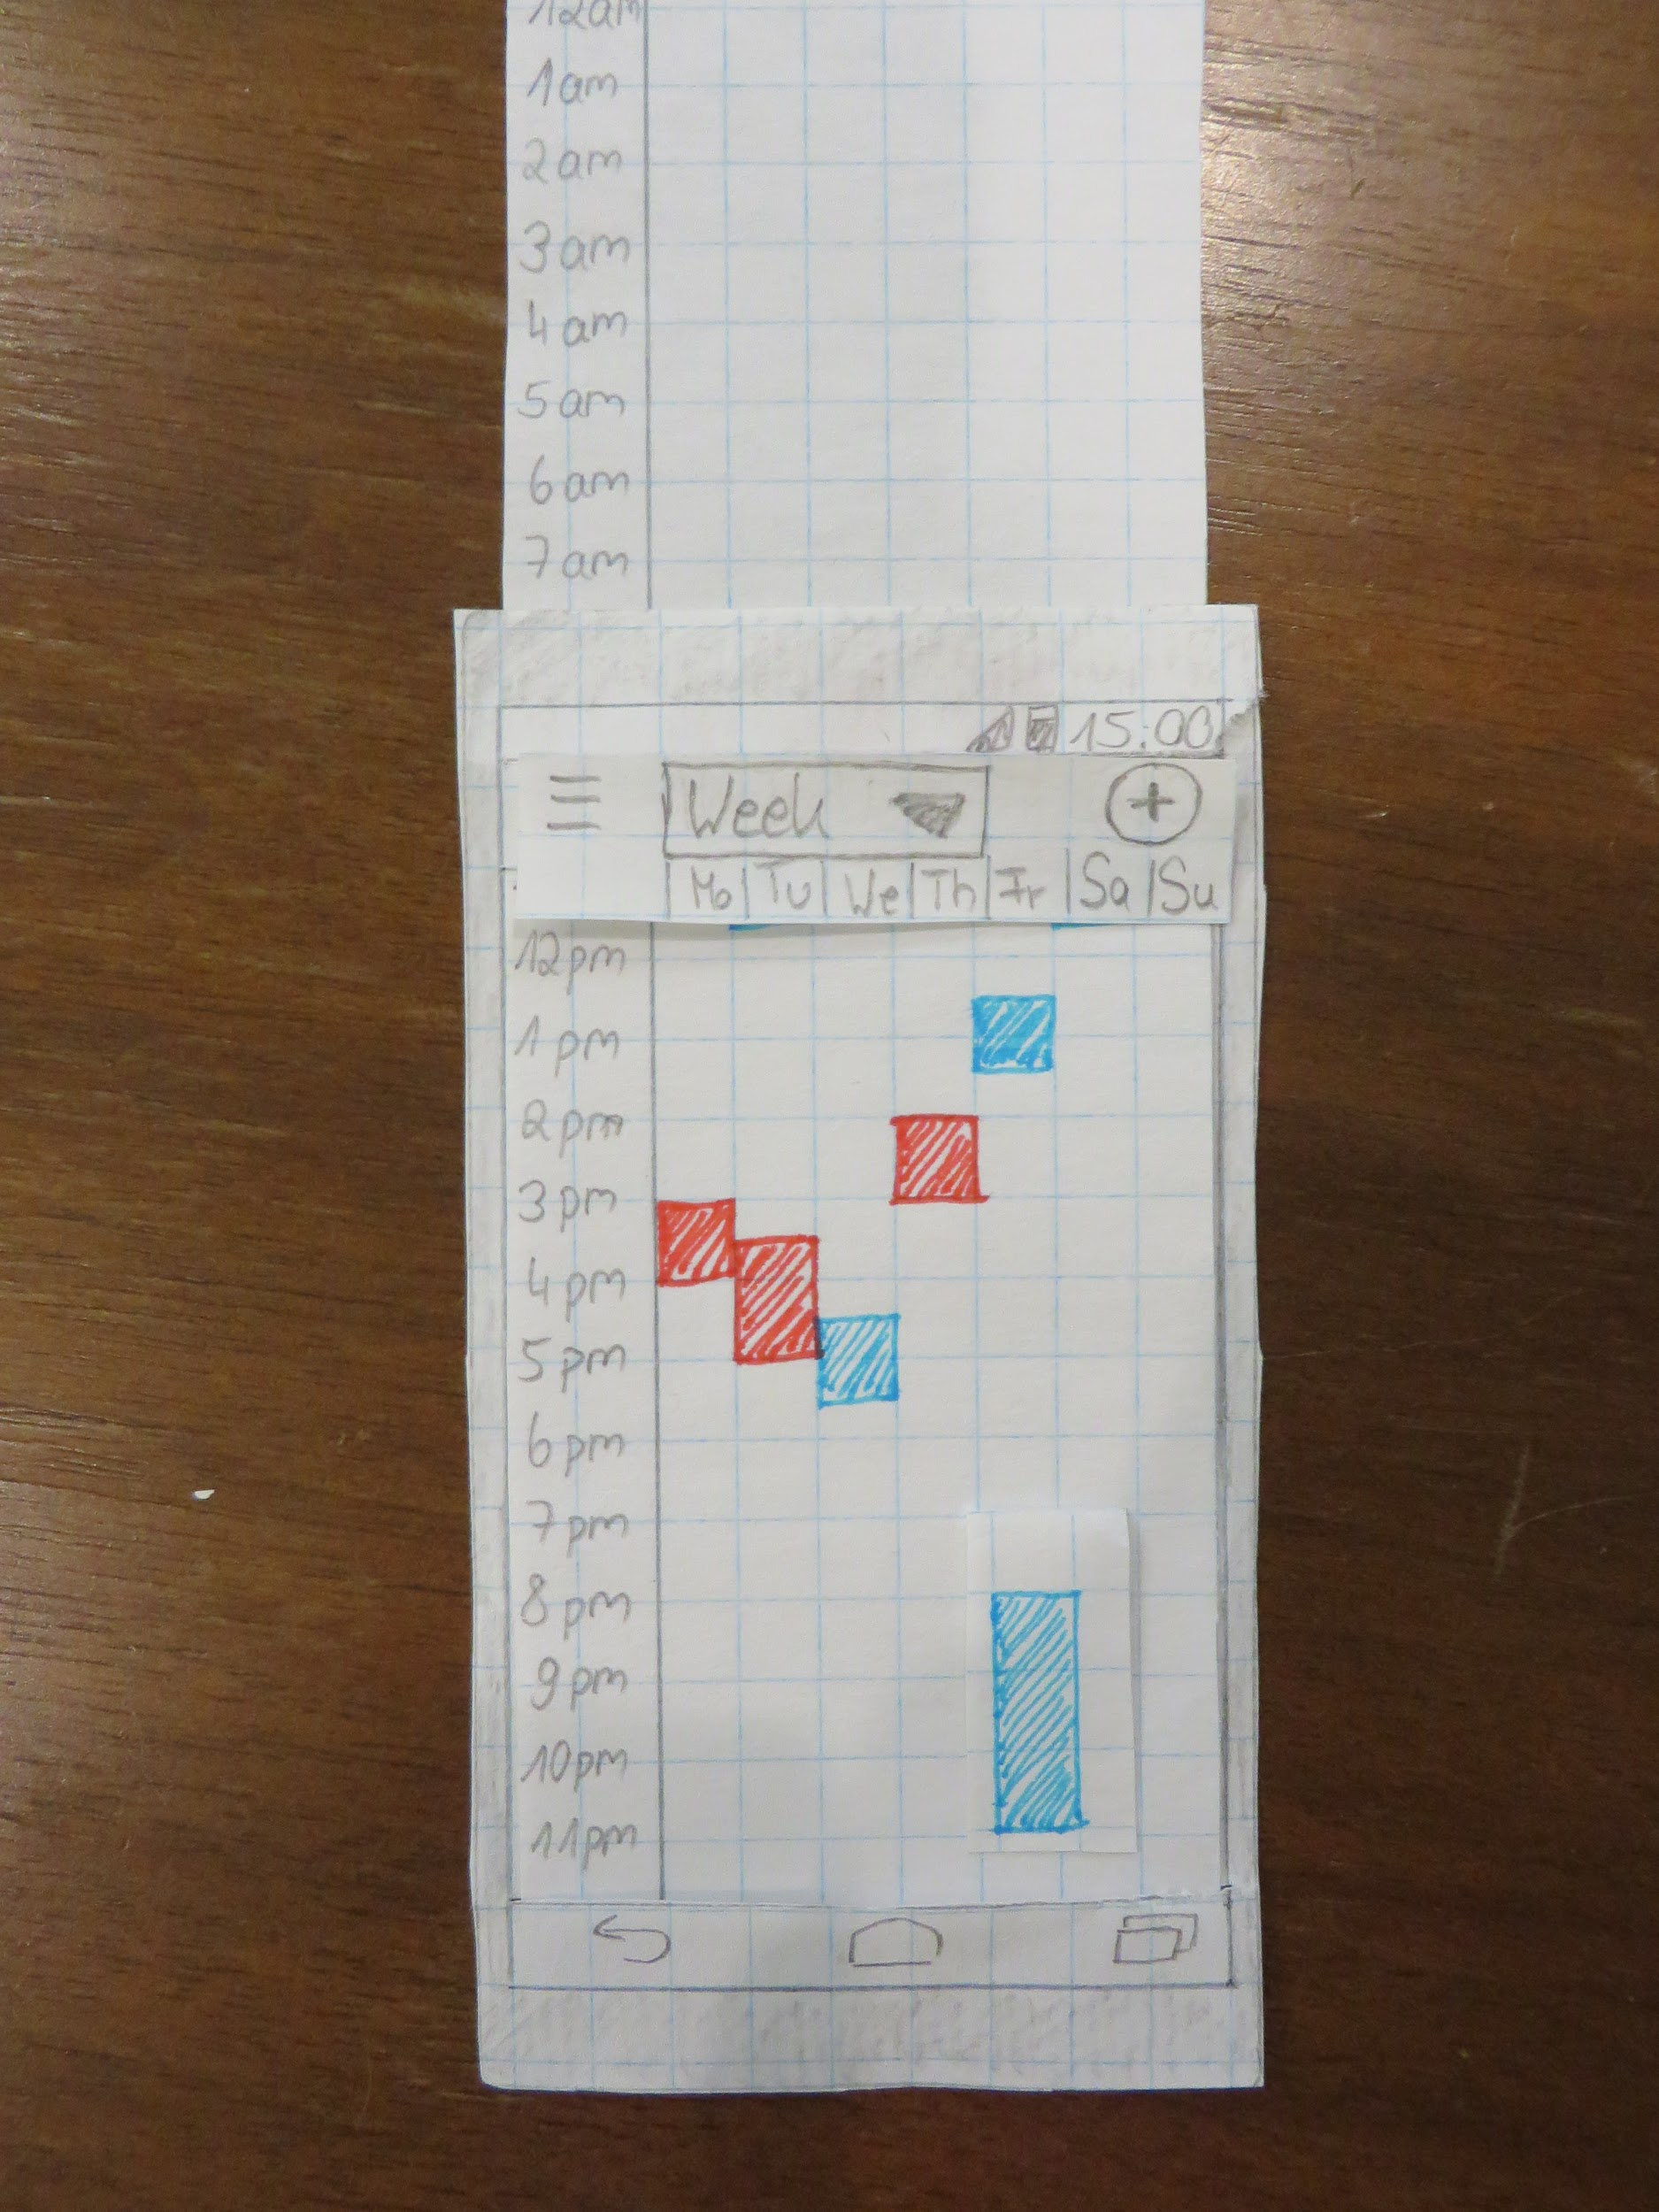

**Initial Evaluation:**

1. User one feedback: The user provided feedback about how an individual would change the time of the event. They asked if you would be clicking the arrows or if it would be a scroll like feature. The user also stated they would prefer a scrollable feature opposed to clicking on the arrows. They also questioned the yearly view option and how it would work. They were curious on if it would take up a lot of space.
2. User two feedback: The user provided feedback about how they would know whose event was whose. For this, they suggested adding a legend. The individual was also curious about all the hamburger menu options and if there would be more or a setting option. Where is the login and logout page? Also, how do you add an individual to the family calendar and what about a settings page?
3. User three feedback: The weekly view should show the date and not only the day of the week.

**Modifications:**

The largest feedback that was received was to remove the yearly view, so we removed the option from the menu. Individuals also suggested a legend to show which events belong to which individual. We added such a legend to the bottom of the screen which should be visible whenever the monthly, weekly or daily view is shown. We also lacked a login and logout page and an option for settings. The settings and option will be located within the hamburger menu. Login will be where the individual is directed if not logged in, which is not shown by this prototype. Another feedback was that it was not intuitive how the time of an event could be changed. Therefore, we decided to use another view representing the time.

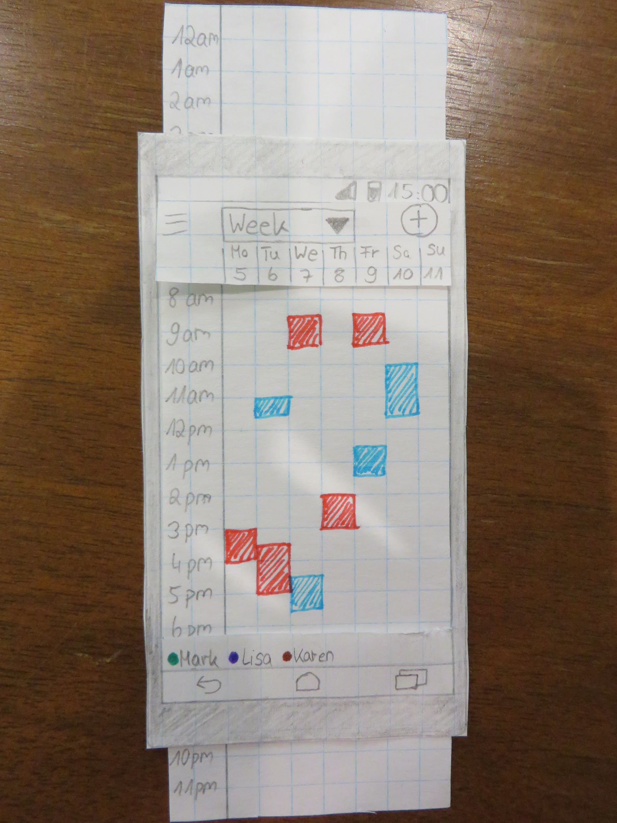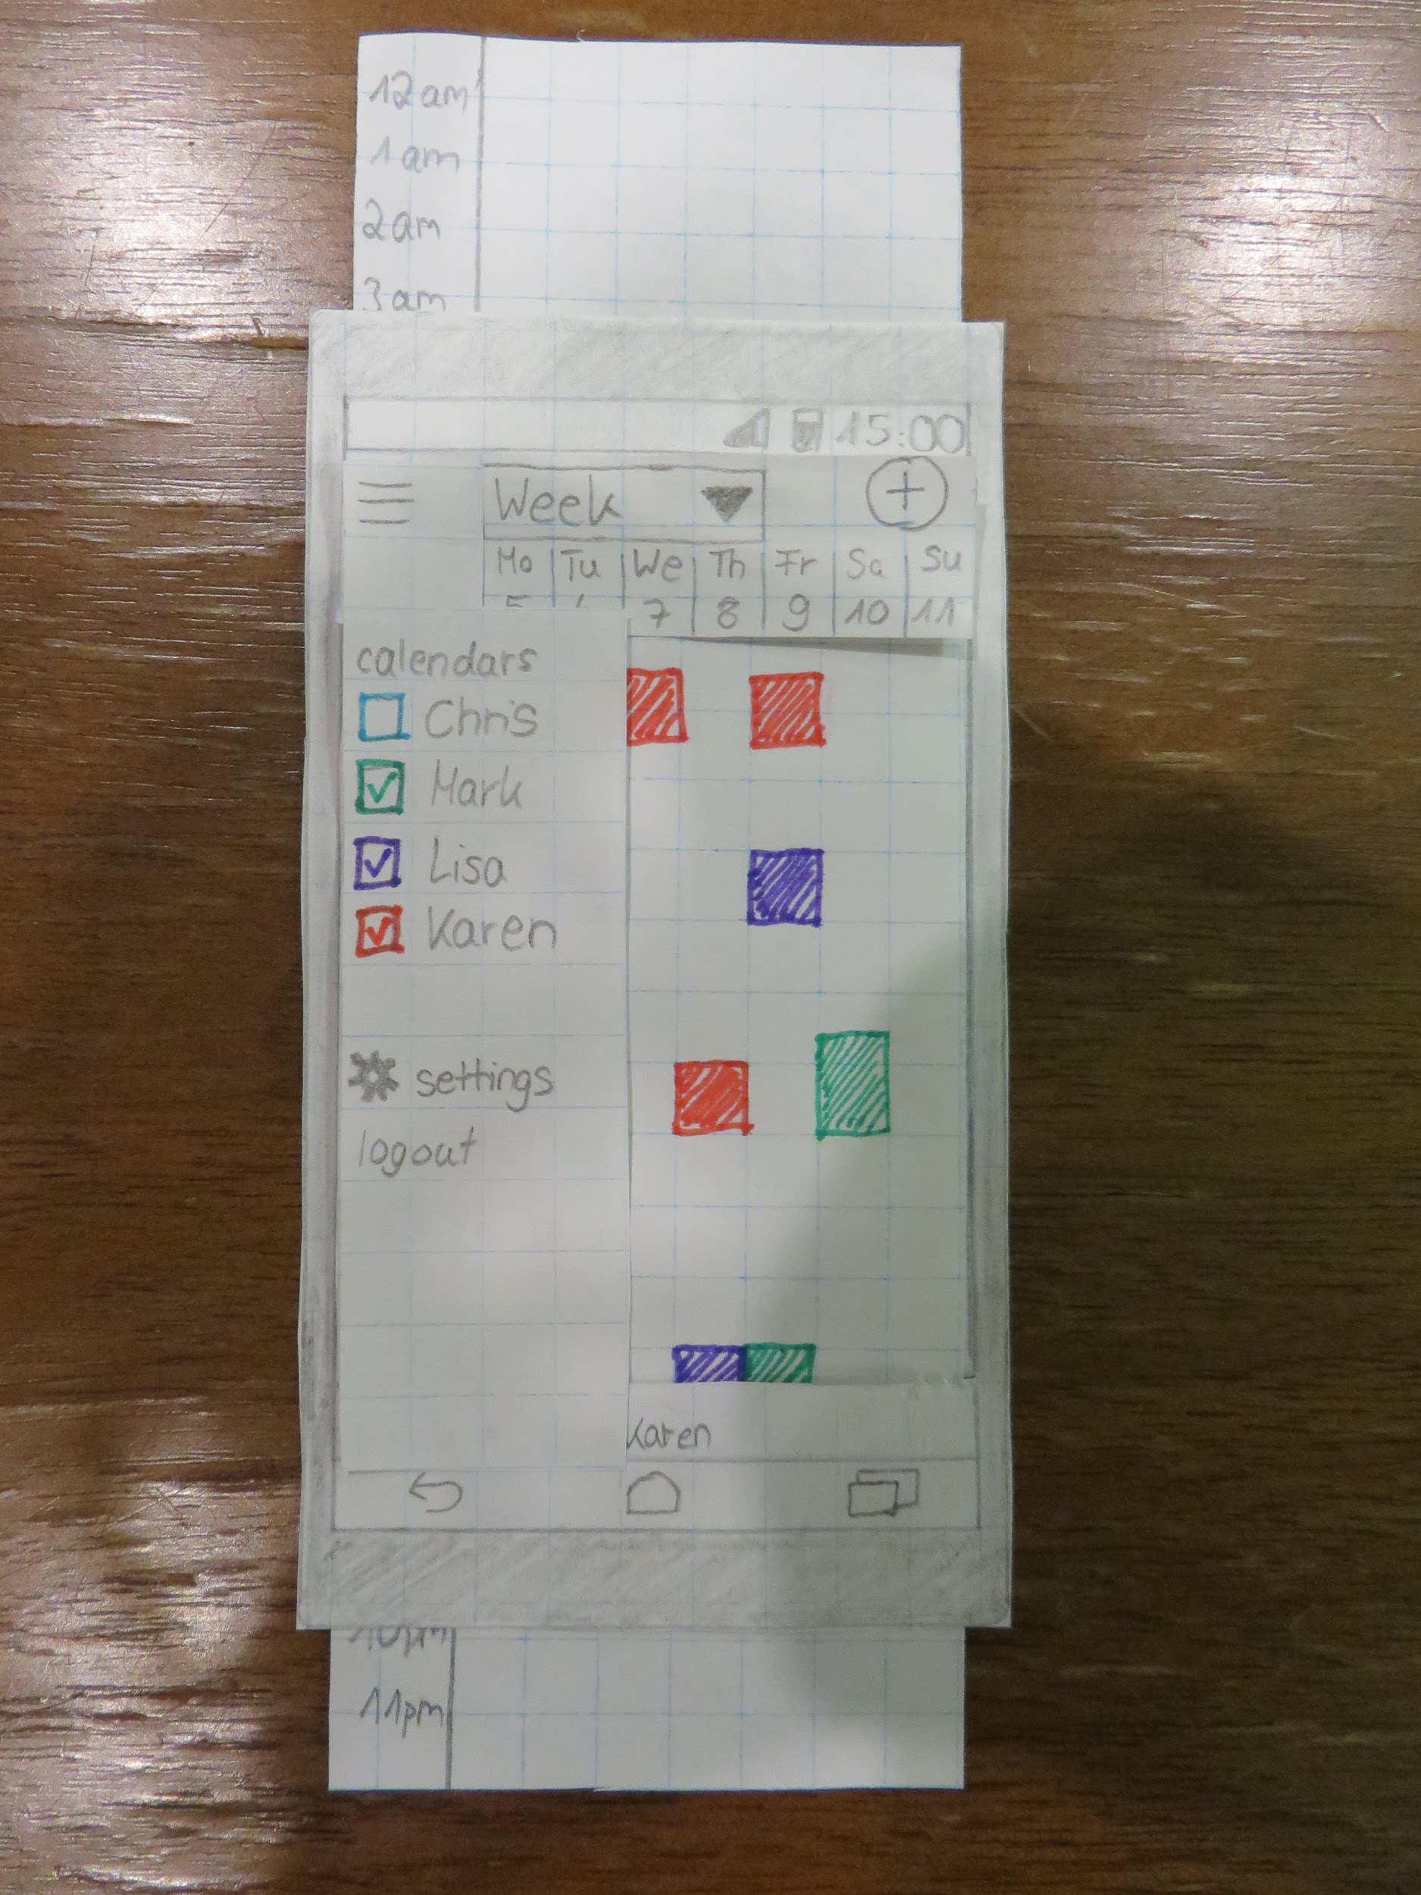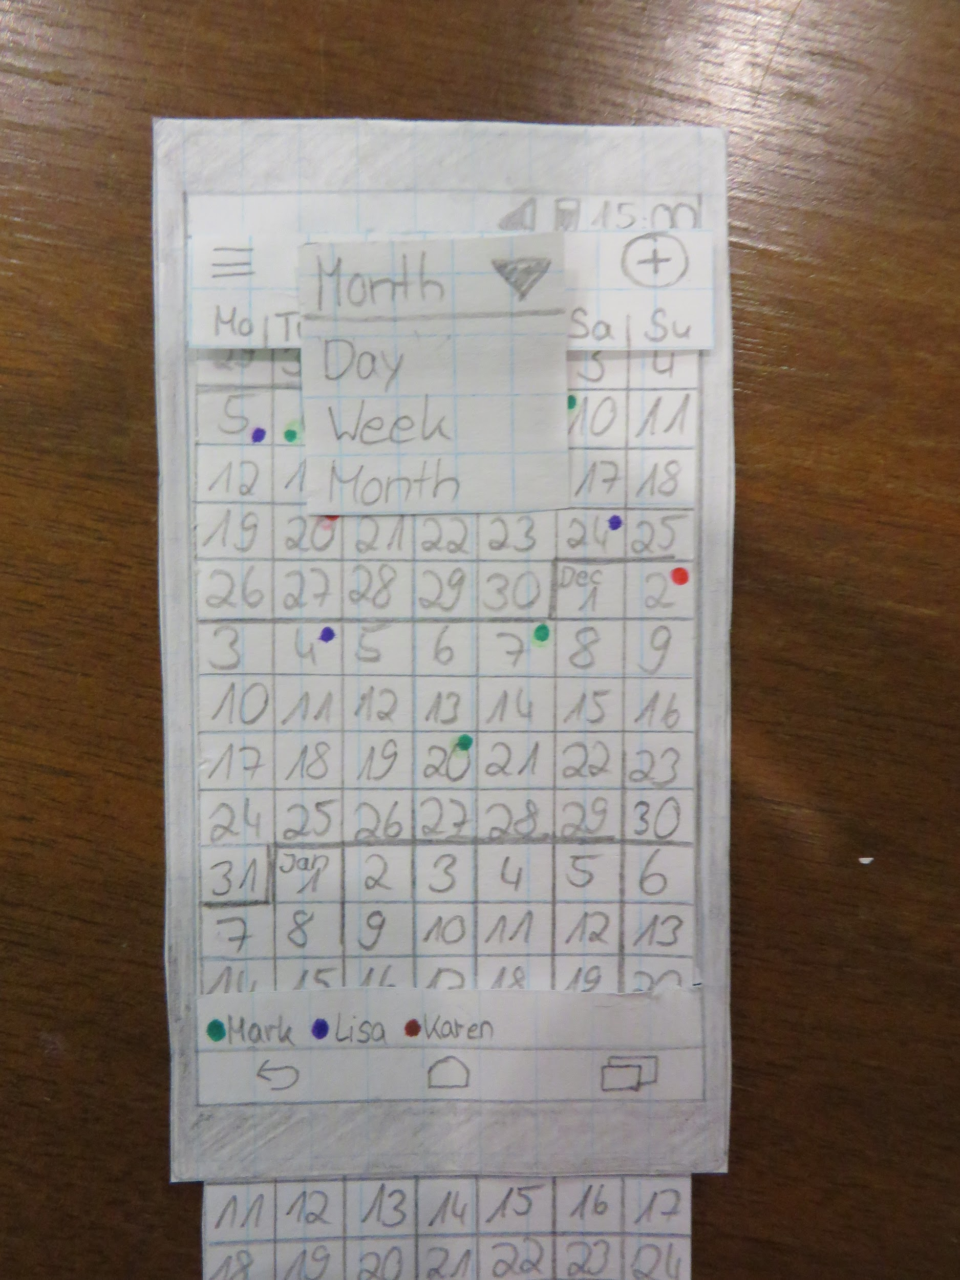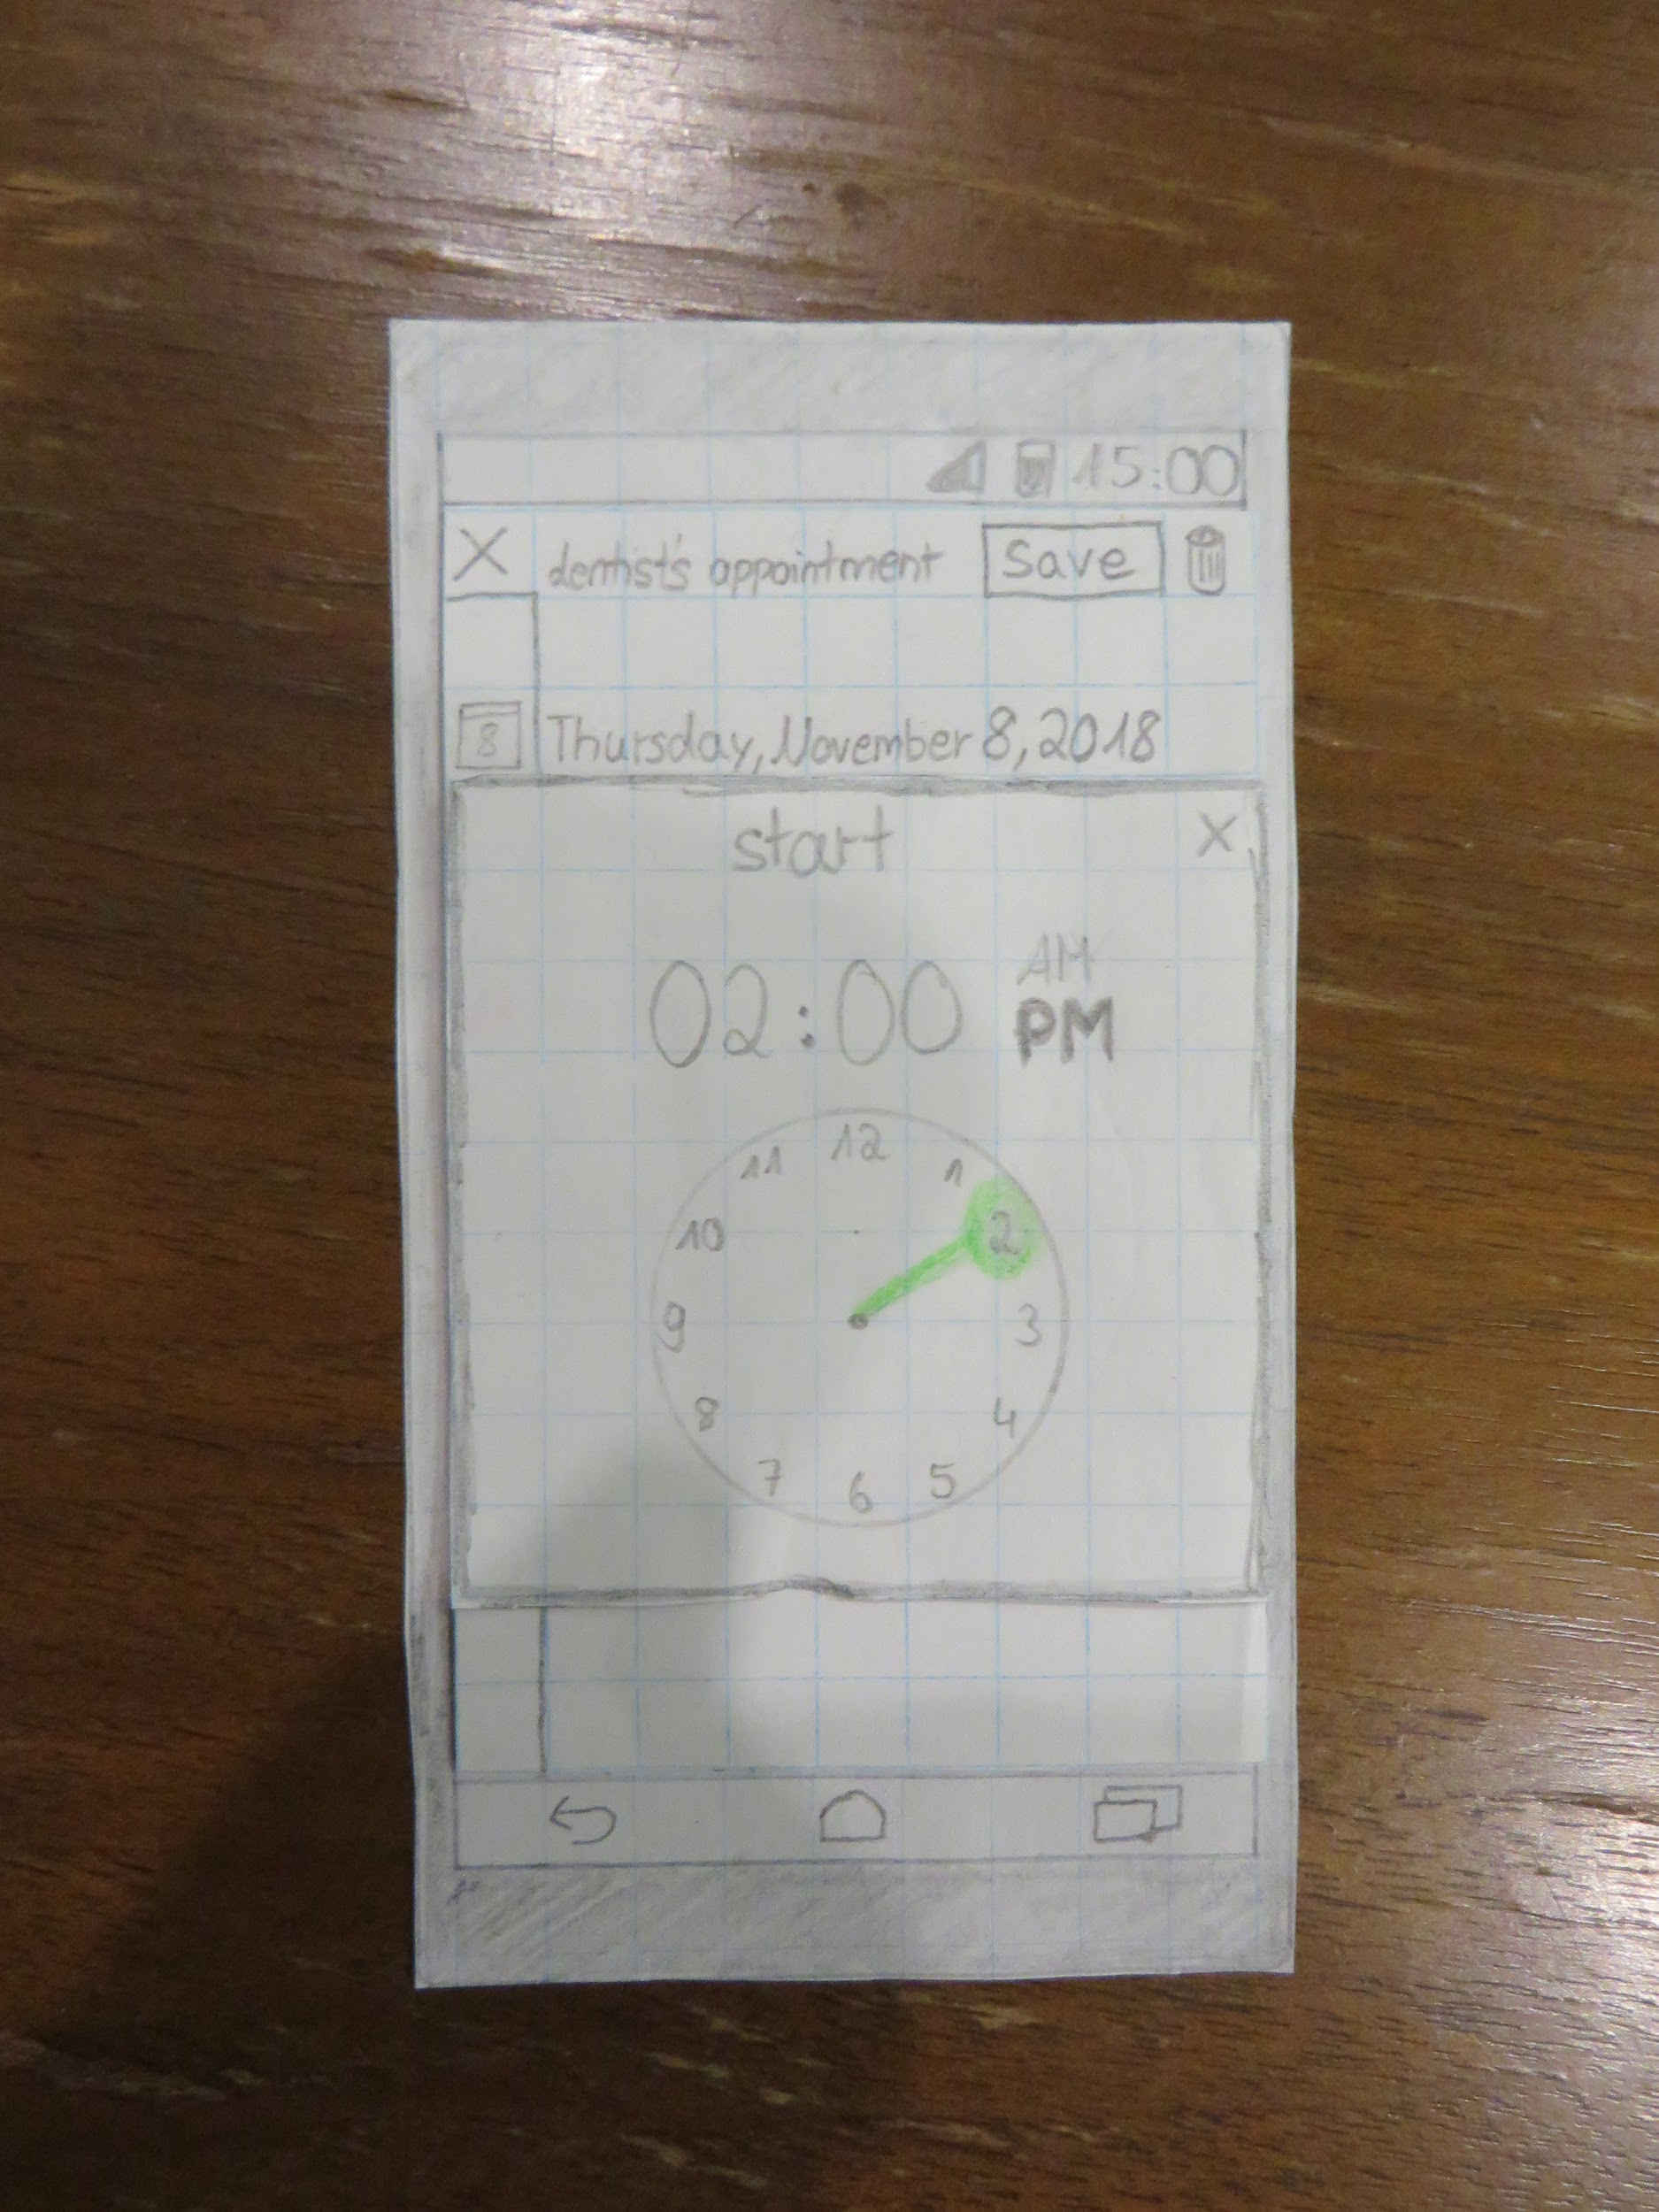

**Second Evaluation**

1. User one feedback: The daily view should be shown when clicking a specific date in the monthly or weekly view so that that specific date is shown and not just any date.
2. User two feedback: The notification about the event adding request should have a hold button so the user can review the schedule before accepting or denying the request. The hamburger menu should provide an option for seeing unanswered requests.
3. User three feedback: The user suggested providing the option of selecting whose calendars to show in the bar for the legend.

**Video link:**

https://youtu.be/r30-svHfNgQ